  Hawaii Landing Page

1. Header Image
   1. We need to change the image – please work with Amy to get the new image
2. Icon Nav Menu – the icons are a little big, I think we can make them smaller. Here are the sections
   1. Impact Data
   2. Equity for All
   3. What’s New
   4. Conference & Celebration
3. Achieve3000 & Hawai’i: 2018-2019 Partnership Pricing
   1. Form - Contact Achieve3000 – Complete this form to get exclusive pricing and more information.
   2. With the Achieve3000 Hawai’i Edition, you can ensure equity and excellence for all PreK-12 students, empowering them to accelerate their literacy gains, achieve success on the SBA, and advance their college and career readiness. Achieve3000 offers the only literacy platform that provides differentiated instruction in 12 levels in English and 8 levels in Spanish across all content areas and uses embedded assessment so students read grade-appropriate content always at their “just-right” Lexile® level. Your Hawai’i Edition delivers a custom curriculum aligned to Hawai’i standards and including special courses for schools using Reading Wonders and SpringBoard. The targeted instruction and practice students need for SBA success start with Achieve3000!
4. The Impact of Our Partnership: Literacy Success in Hawai’I (See flyer and get assets from Amy)

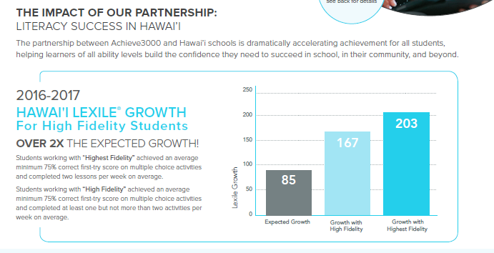

1. Equity for All (See brochure – get assets needed from Amy)

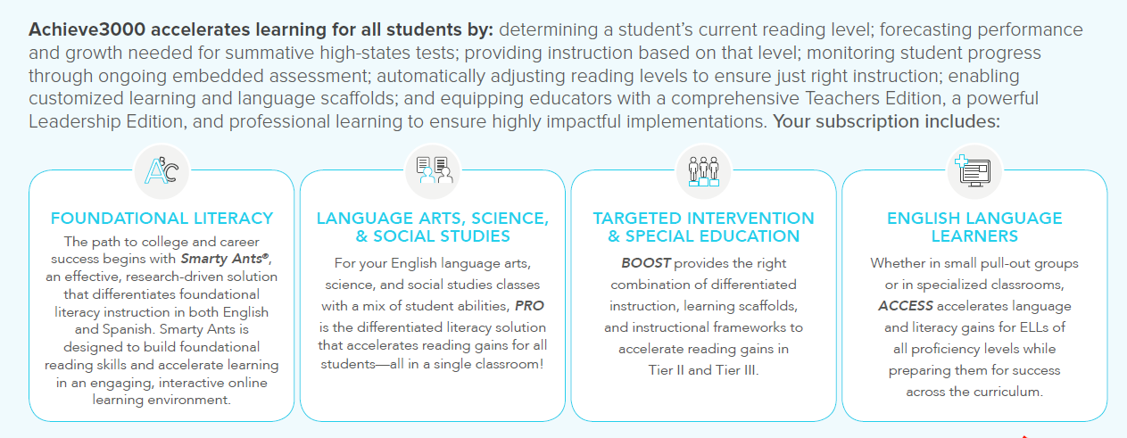

1. What’s New for 2018-2019 – match flyer – request assets from Amy

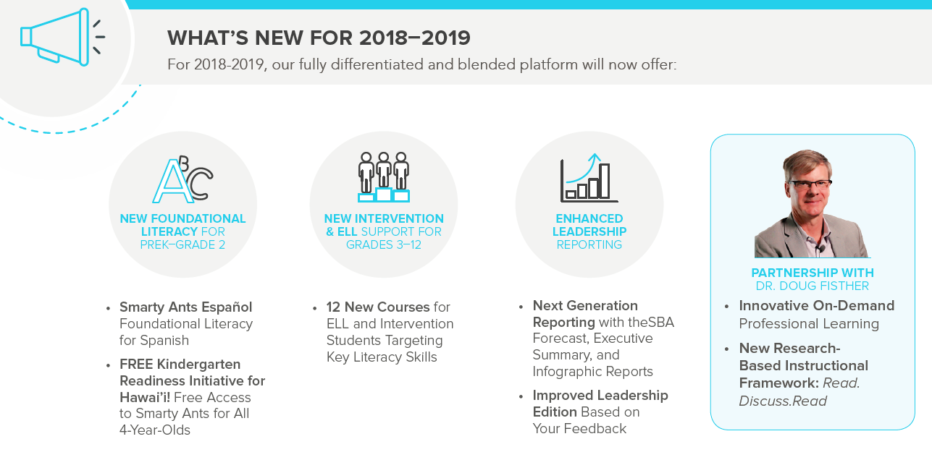

1. HAWAI’I LITERACY LEADERSHIP CONFERENCE & STUDENT CELEBRATION! (Ribbon)

As part of our ongoing partnership, your subscription comes with an invitation to join fellow Achieve3000 education leaders, principals and teachers at our annual Achieve3000 Hawai’i Leadership Conference & Student Celebration for an interactive day of collaboration, exploration, and celebration.

